- Write SELECT INTO statements to create two test tables named VendorCopy and InvoiceCopy that are complete copies of the data in the Vendors and Invoices tables.
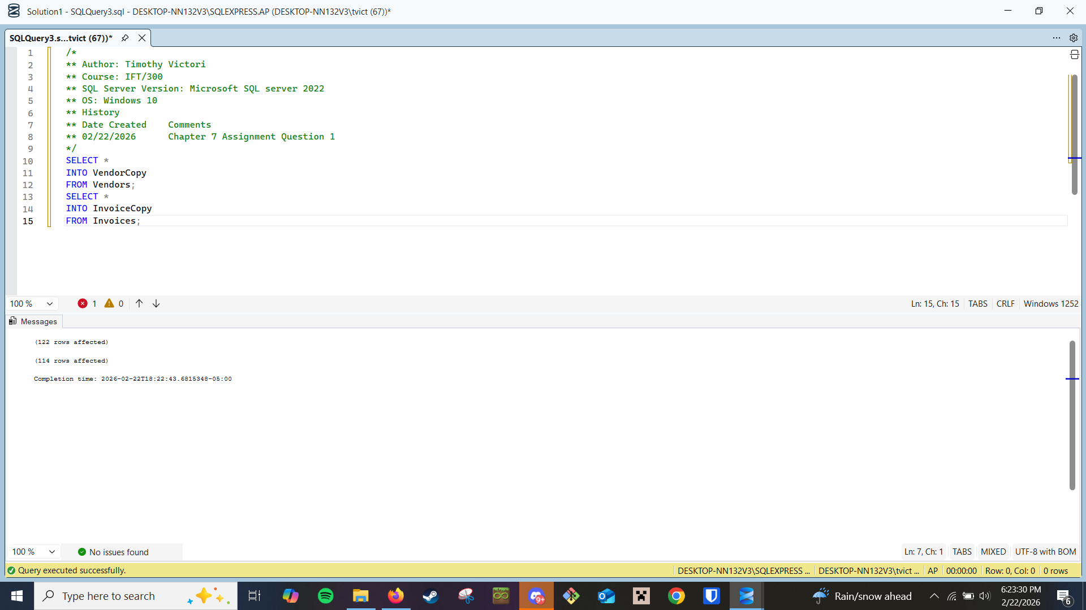
- Write an INSERT statement that adds a row to the InvoiceCopy table with the following values:
VendorID: 32
InvoiceTotal: $434.58
TermsID: 2
InvoiceNumber: AX-014-027
PaymentTotal: $0.00
InvoiceDueDate: 05/8/2023
InvoiceDate: 4/21/2023
CreditTotal: $0.00
PaymentDate: null
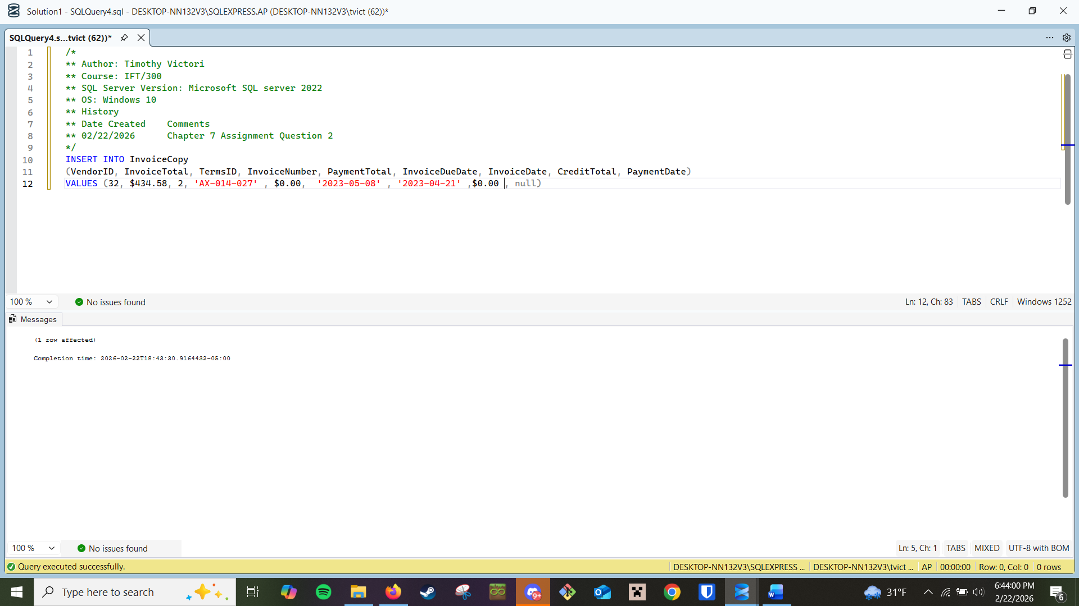
- Write an UPDATE statement that modifies the VendorCopy table. For each vendor that has an account number of 400, change the account number to 403.
